Join the Illinois Self-Advocacy Alliance (The Alliance) and The Arc of Illinois for a day of learning and advocacy including:

* Self-advocacy and how to speak up
* Adult services in Illinois, case management, and navigating the system
* 2019 legislation and policy priorities that could impact you

Trainings are free and will begin promptly at 10am and end at 2pm; lunch is included!

Register at [www.thearcofil.org/events](http://www.thearcofil.org/events) or contact Krescene Beck at the Alliance at [krescenebeck@gmail.com](mailto:krescenebeck@gmail.com) or 618-806-9431.

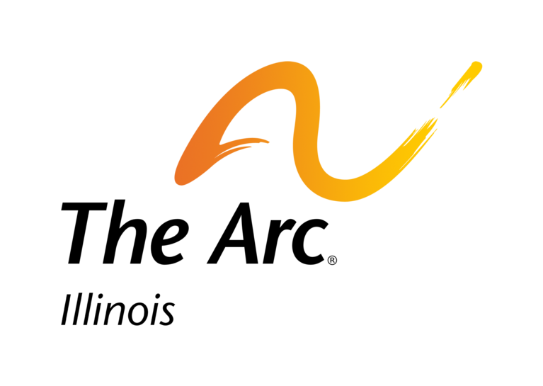

**The Alliance and The Arc of Illinois Spring 2019 Regional Training**

**5 Locations**

**3 Topics**

**1 Purpose**

**“Speaking Up and Speaking Out About Things That Matter to You!”**

February 26, 2019

Davis-McCann Center

5 North 14th Street

Murphysboro, IL

March 5, 2019

KCCDD

2015 Windish Drive (Unit 8 on Lowrey Drive)

Galesburg, IL

March 19, 2019

Memorial Center for Learning and Innovation

228 West Miller Street

Springfield, IL

March 20, 2019

Knight of Columbus

100 S. 129th Infantry Drive

Joliet, IL

March 26, 2019

Knights of Columbus

15 N. Hickory Avenue

Arlington Heights, IL

**Registration is limited to 75 at each location.**

This regional training was developed under an investment by the Illinois Council on Developmental Disabilities (ICDD).



**The Alliance and The Arc of Illinois Spring 2019 Regional Training**

**Please check date/location attending**

____ February 26, 2019 ____ March 5, 2019 ____ March 19, 2019

Davis-McCann Center KCCDD MCLI

Murphysboro, IL Galesburg, IL Springfield, IL

____ March 20, 2019 ____ March 26, 2019

Knights of Columbus Knights of Columbus

Joliet, IL Arlington Heights, IL

Agency/Group /Family Name______________________________________________

Address_______________________________________________________________

Contact Person Name____________________________ Phone__________________

E-mail ________________________________________________________________

Total Number Attending (include self-advocates, allies, support staff, family members:______

Accommodation Requests (box lunches will be provided to all participants):

___ Dietary requirements – please specify. NOTE: Any physician-prescribed dietary requirements will be accommodated; food preferences will not be honored_______________________________________________________________

______________________________________________________________________

___ Other requests – please specify________________________________________

_____________________________________________________________________

All materials will be available in 14 point font.

**Please register at least 3 weeks before the training you wish to attend.**

Krescene Beck Mail: 6754 Middlegate Lane, Glen Carbon, IL 62034

Email: krescenebeck@gmail.com

Phone: 618.806.9431