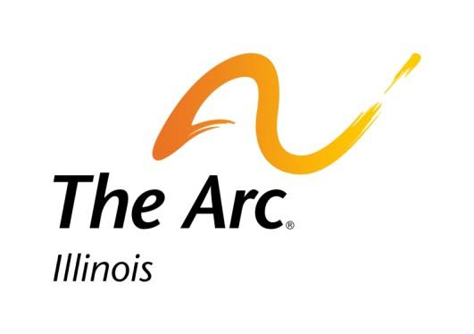

POLICY AND ADVOCACY PRIORITIES
THE ARC OF ILLINOIS

Since 1955, The Arc of Illinois has been committed to empowering persons with disabilities to achieve full participation in community life.

Our 2020 policy and advocacy priorities include supporting legislation, policy and systems change and advocating for:

- Increased Investment in Community Living
The Arc of Illinois believes Illinois must increase investment in I/DD home and community-based supports through increased wages and rates that reflect people’s support needs in individualized and inclusive ways. Illinois must address the issue of equity – ensuring that people can receive the appropriate level of supports in the community and not just in institutions. Illinois should utilize an universal assessment for all people with I/DD so that we can better understand the needs of the people receiving services regardless of where they live. We also want to see expanded investment in DD grants including Life Span, Family Advocacy, The Autism Program, Epilepsy, Best Buddies and Respite.

Ending the Waiting List for Services
The Arc believes that no one should wait for services and supports that provide the opportunity for community living. All waiting lists, especially the PUNS waiting list should be eliminated by the timely provision of services and supports for people with I/DD in the most integrated setting under a person-centered plan. We continue to advocate for a more transparent and easier system for individuals and families to navigate. This includes improving the administration, tracking and engagement of those currently on the PUNS waiting list or eligible but not aware of the list.

Fiscally Prudent Spending on Long Term Services
The Arc believes that state funding for persons with I/DD must follow the needs and desires of the people it serves and reflect a fiscally responsible approach. A funding model that recognizes community supports as the preferred model must be implemented statewide. Illinois should develop a short-term transition plan for shifting federal and state funding from state developmental centers to community living.

Expanded Employment First
The Arc believes that people should receive adequate supports in order to achieve competitive integrated employment. Illinois should embrace the commitment it made in becoming an Employment First state by implementing the Employment Task Force’s recommendations. We should improve the implementation of the Workforce Innovations Opportunity Act to ensure that competitive integrated employment is available for transition age youth and people in subminimum wage. We believe Illinois needs to increase investment in supported employment, begin funding customized employment, support training for transition age youth and families and expand access to transportation services, while improving how DRS, DDD, ISBE and schools work together to support families. All employment and day services should reflect the federal HCBS settings rule.

Implementation of the HCBS Settings Rule

The Arc believes Illinois should immediately convene stakeholders to review the current draft transition plan and offer input into an update of that plan. The HCBS settings rules will come into effect by 2022, and Illinois is incredibly unprepared, lacking a transition plan and not having communicated formally with stakeholders in more than three years. This must change in order to fully implement the rule especially for services and supports for people with I/DD. With limited funds for home and community-based services, it is very important that all these dollars go to services that encourage independence, self-direction, and individualized and community-integrated supports.

Health Care
We will continue to oppose the expansion of Medicaid managed care to intellectual and developmental disabilities home and community-based services and have significant concerns about the consolidation of the Medicaid managed care. We will work with Healthcare and Family Services to advocate for network adequacy and an increased understanding by the Department and MCOs about working with people of all ages with I/DD. This also includes improving the Medicaid eligibility system to work better for people with I/DD. In addition, we support improvements in the system so that people with I/DD who has have behavioral support needs can have access to the appropriate services.

Expanded Use of Assistive Technology
We advocate for expansion of the use of assistive technology toward independence of people with disabilities and more flexible support options. Illinois should become a Technology First state, leading with technology for independence.

Improved Access to Quality Education and Support for Youth with Disabilities

The Arc believes children and youth with I/DD should have access to high quality and trained staff support that ensure they can learn and grow in inclusive schools. We support the state’s review of data around seclusion and restraint, changes to law and regulations to limit the use of seclusion and restraint, and increased funding for training and adequate staffing supports.

For more information, please contact Meg Cooch at meg@thearcofil.org.

FY2020 Administrative and Legislative Priorities:
- Employment
  - Let people live in CILA keep their paychecks and hold providers harmless
  - Raise PNA to $100
  - Data collection around WIOA implementation
- Seclusion and Restraint Bill (joint with ISBE/coalition)
- Transition age youth bridge supports waiver
- TRS – pension fix for retired teachers with kids with disabilities
- Supported Decision Making (with Guardianship and Advocacy)
- Budget - Wage Increase/Rate Increase to Reflect the Staffing Crisis and Need to Address Community Capacity (with They Deserve More)
- Budget – Fund Diversion Homes
- Assistive Technology – Remote Supports (with IARF)

Administration Advocacy:
- Medicaid Re-Determination Issues
- Ending Non certified homes
- Universal assessments/Universal person-centered planning (still determining if it is possible without legislation)
- HCBS Settings rule stakeholder meetings
- Chicago move away from subminimum wage

Federal Advocacy:
- Money Follows the Person
- Increase income and asset limits so that people with disabilities can gain employment without fear of losing benefits
- HCBS Infrastructure Bill

