Self-Advocacy Groups Taking Care of Business:
Tips and Strategies for Successful Online Meetings

Choose an Online Platform
- Zoom
  - Free and easy to use
  - Widely used due to COVID
  - Free account limited to 40 minute maximum per meeting
  - Can pay for more time and options
- Google Meet
  - Free
  - Host must have Google account such as Gmail to host meeting
  - Has captioning available

Advance Planning Strategies to Make the Online Meeting Run Smoothly
- Decide which online platform will be used
- Practice using online platform with participants prior to meetings
- Prepare a clear agenda
- Assign tasks/roles to different participants such as note taker, chat monitor, meeting facilitator
- Send out meeting agenda and information on how to join the meeting at least one week in advance

- Send information and instructions on how to join the meeting including links and call-in numbers Including, meeting links, call in numbers
- Send out meeting reminder a few days before the meeting with related materials such as agenda, task assignments, meeting links, and call in numbers
- Set up meeting so all participants start on mute to reduce background noise

Tips for a Productive Online Meeting
- Have an agenda
- Start on time and keep to the schedule
- One person talks at a time.
- Say your name when you speak, example “This is Jae, and I want to say…”
- Join meeting from one device

Illinois Self-Advocacy Alliance, Inc. (The Alliance)
P.O. Box 666 Park Forest, Illinois 60466 Email: info@selfadvocacyalliance.org
Website: www.selfadvocacyalliance.org Find us on Facebook at Illinois Self-Advocacy Alliance

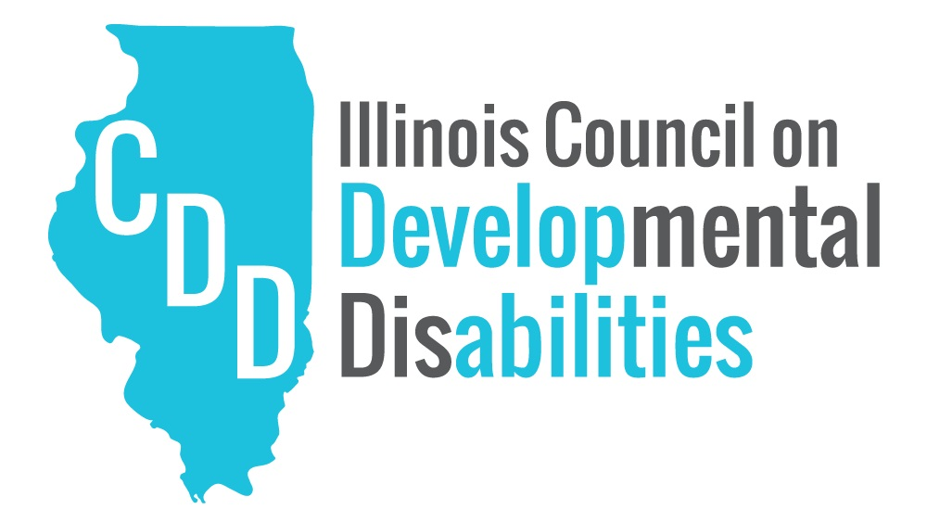
The Illinois Self-Advocacy Alliance, Inc. (The Alliance) is proud to be an initiative of the Illinois Council on Developmental Disabilities. In partnership with the Illinois Council on Developmental Disabilities. This project was supported, in part by grant numbers 19/2001ILSCDD-02, from the U.S. Administration for Community Living, Department of Health and Human Services, Washington, D.C. 20201. Grantees undertaking projects with government sponsorship are encouraged to express freely their findings and conclusions. Points of view or opinions do not, therefore, necessarily represent official ACL policy.
August 2020

